**ST.XAVIER’S COLLEGE**

MAITIGHAR, KATHMANDU



Computer Graphics

Assignment #2

Submitted By:

Aabhash Dhakal

013BSCCSIT001

2nd year/ 4th semester

Submitted to:

|  |  |
| --- | --- |
| Er. Anil K. Sah  Lecturer  Department of Computer Science |  |

**STATEMENT**

Write a program to draw and implement a functioning calculator using C++ builder.

­

**SOURCE CODE**

//---------------------------------------------------------------------------

#include <vcl\vcl.h>

#pragma hdrstop

#include "Unit1.h"

//---------------------------------------------------------------------------

#pragma package(smart_init)

#pragma resource "*.dfm"

TForm1 *Form1;

int a,b,c;

int f = 0, o;

//---------------------------------------------------------------------------

__fastcall TForm1::TForm1(TComponent* Owner)

: TForm(Owner)

{

}

int setval(int x)

{

if (f==0)

{

a = x;

f = 1;

return a;

}

else

{

b = x;

f = 0;

return b;

}

}

int resetval(int y)

{

c = 0;

c = y;

return c;

}

//---------------------------------------------------------------------------

void __fastcall TForm1::B9Click(TObject *Sender)

{

RB->Text = setval(9);

}

//---------------------------------------------------------------------------

void __fastcall TForm1::B8Click(TObject *Sender)

{

RB->Text = setval(8);

}

//---------------------------------------------------------------------------

void __fastcall TForm1::B7Click(TObject *Sender)

{

RB->Text = setval(7);

}

//---------------------------------------------------------------------------

void __fastcall TForm1::B6Click(TObject *Sender)

{

RB->Text = setval(6);

}

//---------------------------------------------------------------------------

void __fastcall TForm1::B5Click(TObject *Sender)

{

RB->Text = setval(5);

}

//---------------------------------------------------------------------------

void __fastcall TForm1::B4Click(TObject *Sender)

{

RB->Text = setval(4);

}

//---------------------------------------------------------------------------

void __fastcall TForm1::B3Click(TObject *Sender)

{

RB->Text = setval(3);

}

//---------------------------------------------------------------------------

void __fastcall TForm1::B2Click(TObject *Sender)

{

RB->Text = setval(2);

}

//---------------------------------------------------------------------------

void __fastcall TForm1::B1Click(TObject *Sender)

{

RB->Text = setval(1);

}

//---------------------------------------------------------------------------

void __fastcall TForm1::B0Click(TObject *Sender)

{

RB->Text = setval(0);

}

//---------------------------------------------------------------------------

void __fastcall TForm1::B_EClick(TObject *Sender)

{

switch(o)

{

case 1:

c = a + b;

break;

case 2:

c = a - b;

break;

case 3:

c = a * b;

break;

case 4:

c = a/b;

break;

}

RB->Text = c;

}

//---------------------------------------------------------------------------

void __fastcall TForm1::B_MClick(TObject *Sender)

{

o = 3;

}

//---------------------------------------------------------------------------

void __fastcall TForm1::B_DClick(TObject *Sender)

{

o = 4;

}

//---------------------------------------------------------------------------

void __fastcall TForm1::B_AClick(TObject *Sender)

{

o = 1;

}

//---------------------------------------------------------------------------

void __fastcall TForm1::B_SClick(TObject *Sender)

{

o = 2;

}

//---------------------------------------------------------------------------

void __fastcall TForm1::B_ACClick(TObject *Sender)

{

RB->Text = resetval(0);

}

//---------------------------------------------------------------------------

**OUTPUT SCREENS**

**AddITION**

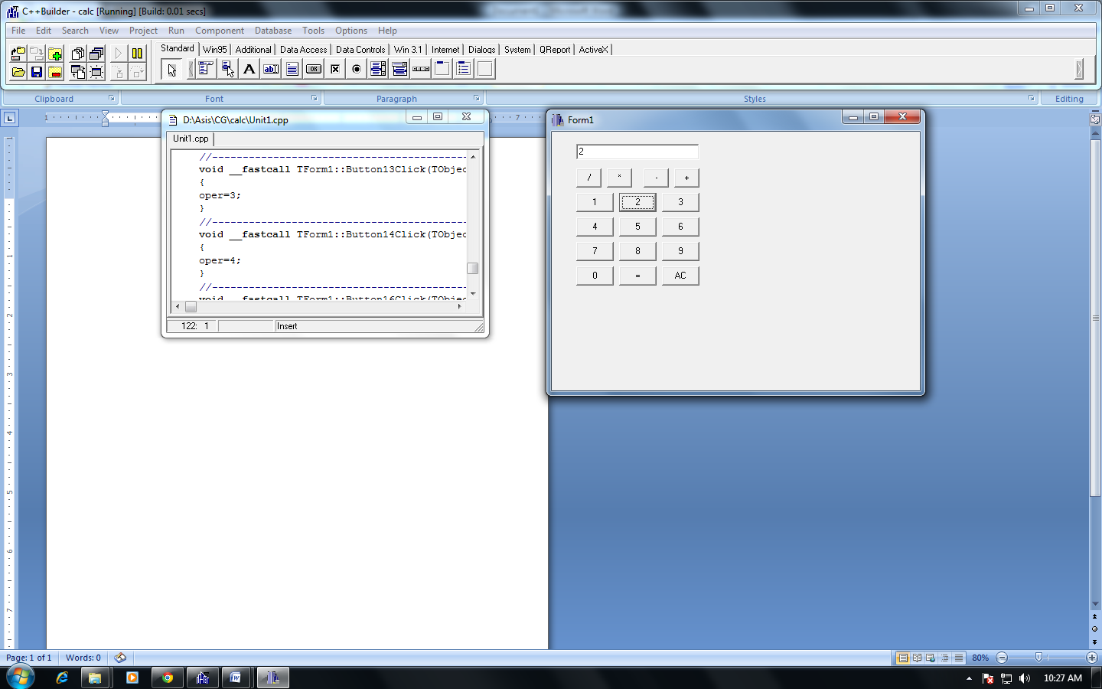

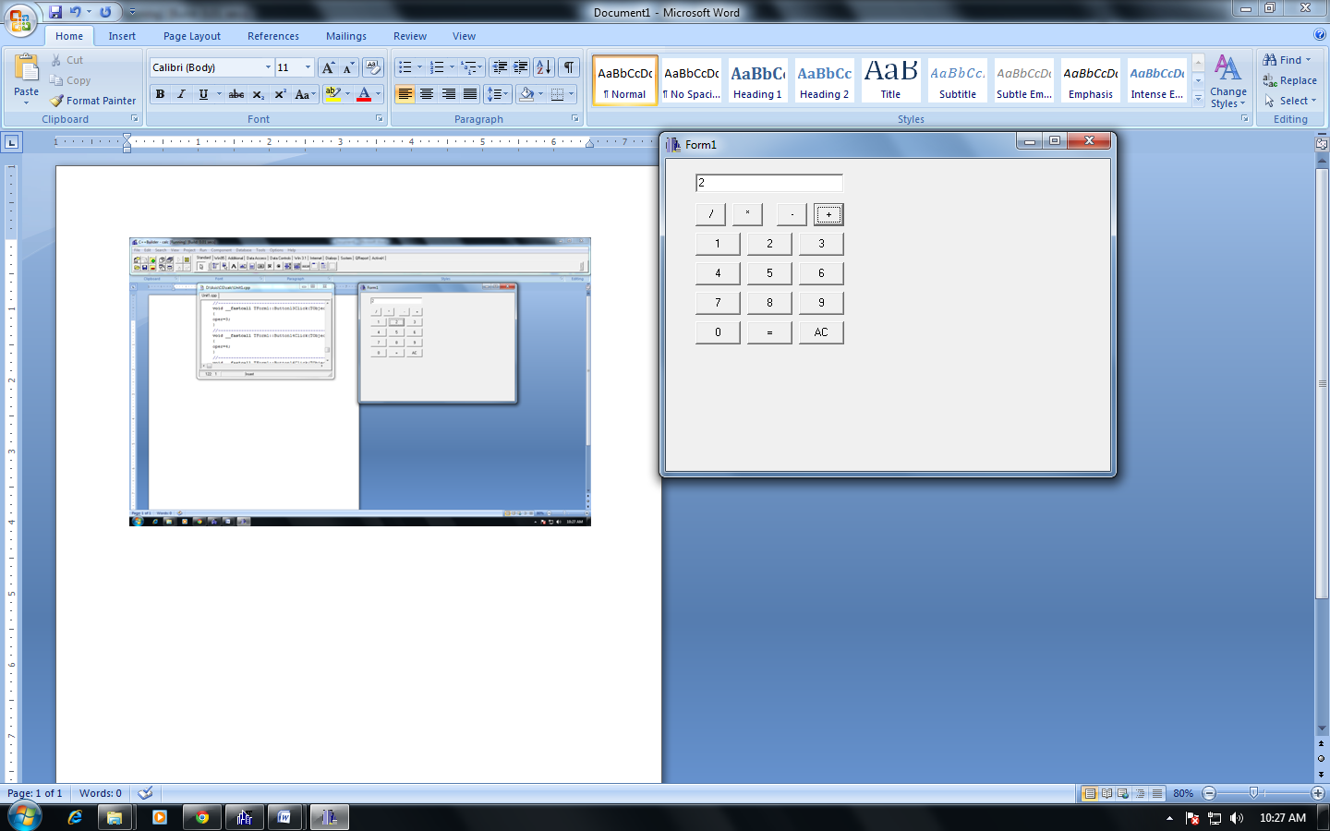

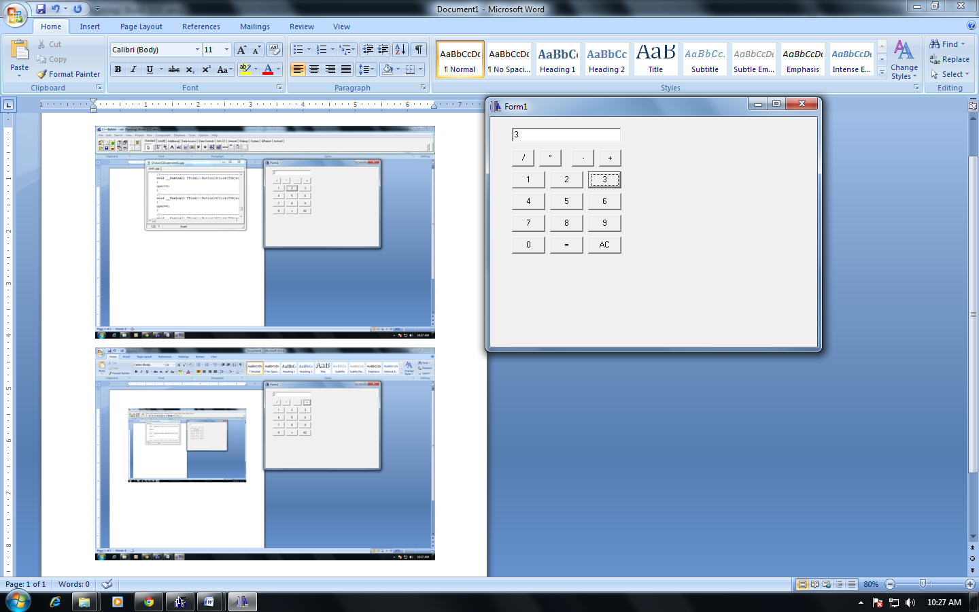

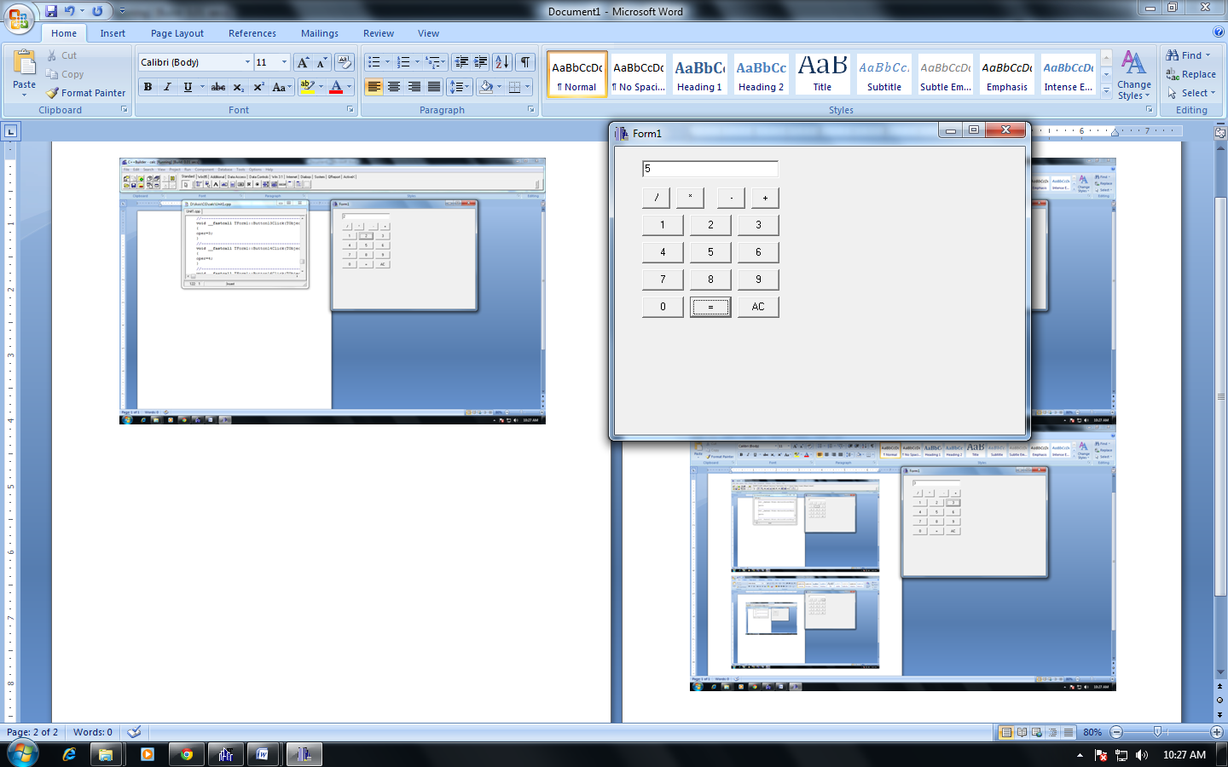

**SUBTRACTion**

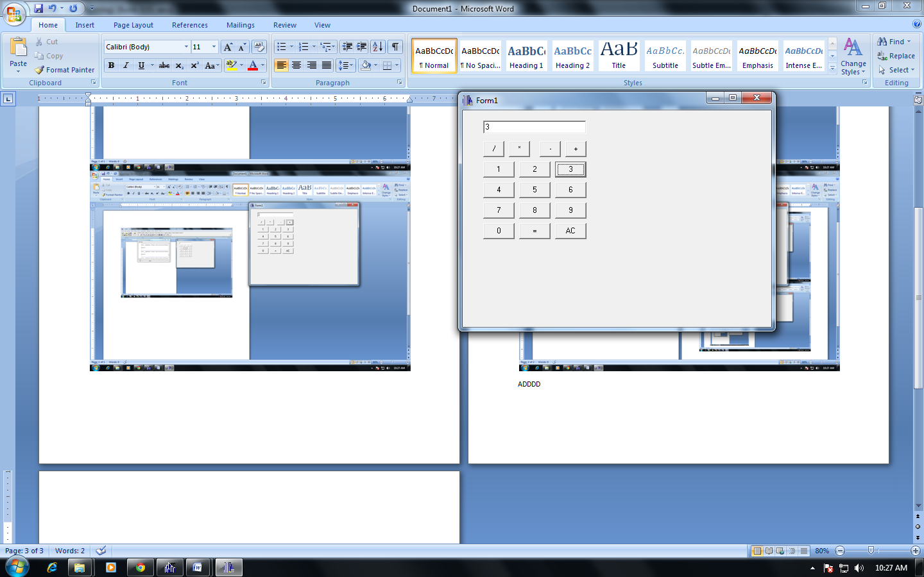

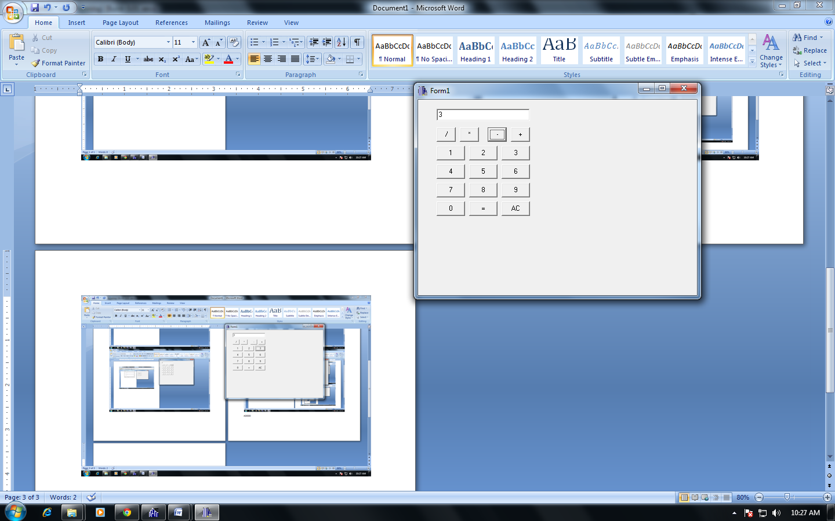

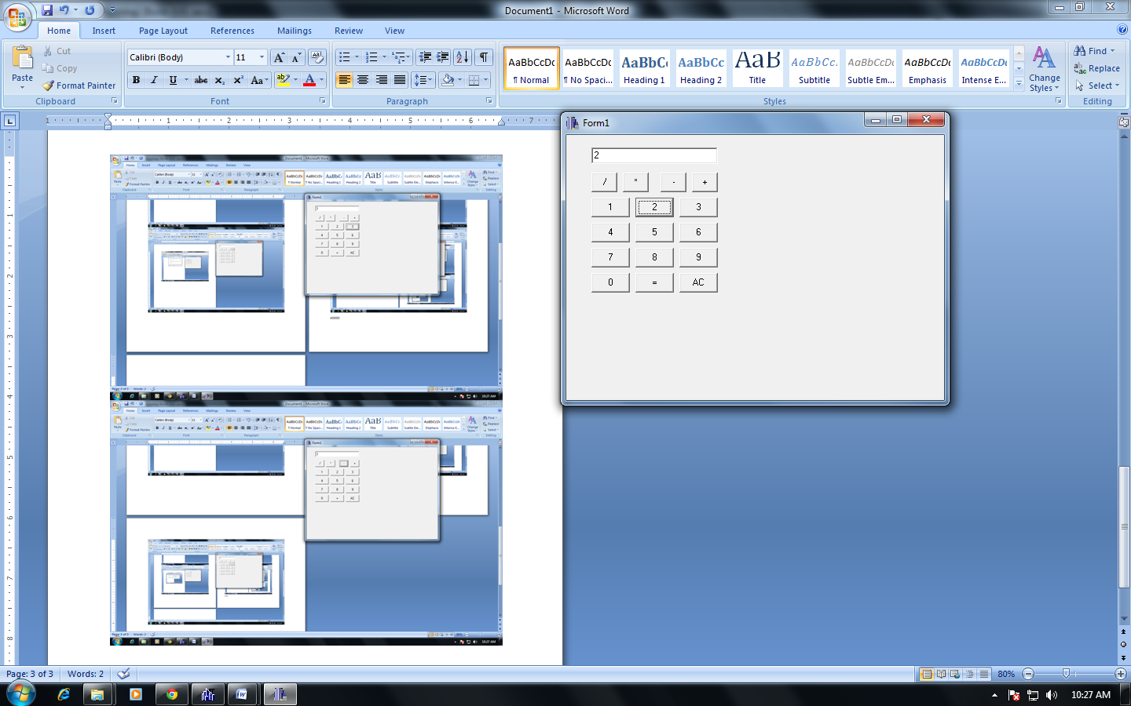

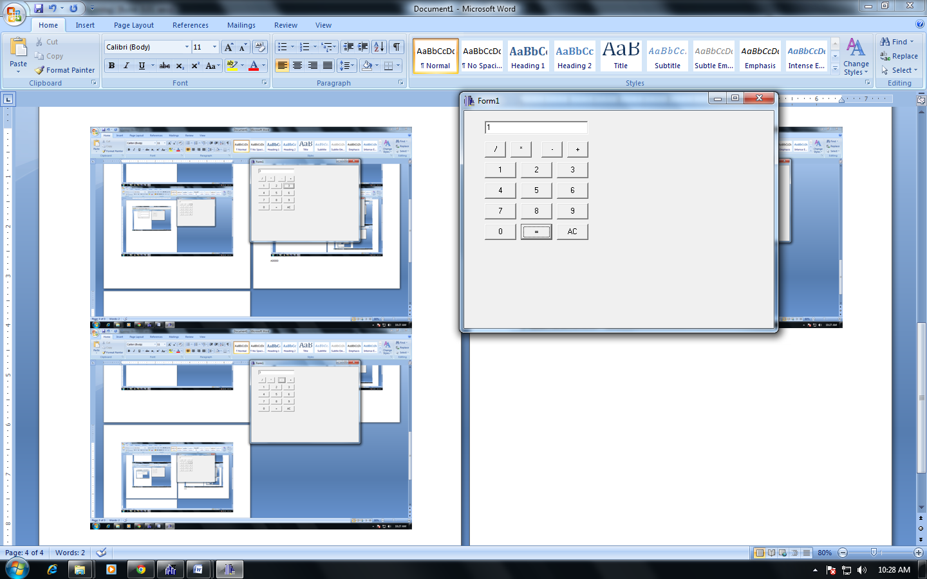

**Multiplication**

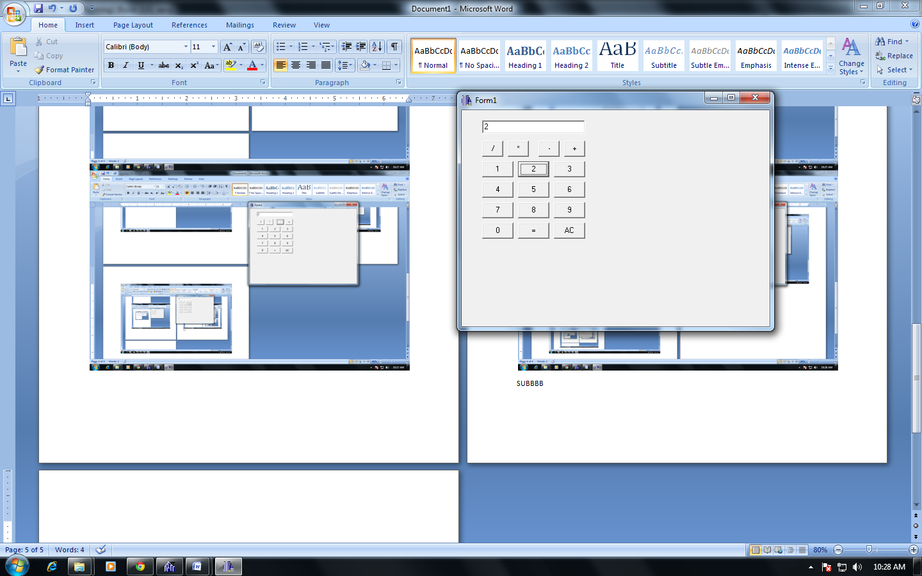

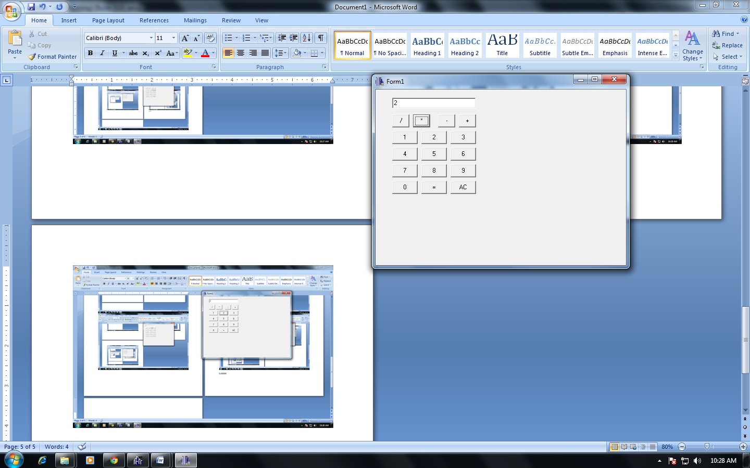

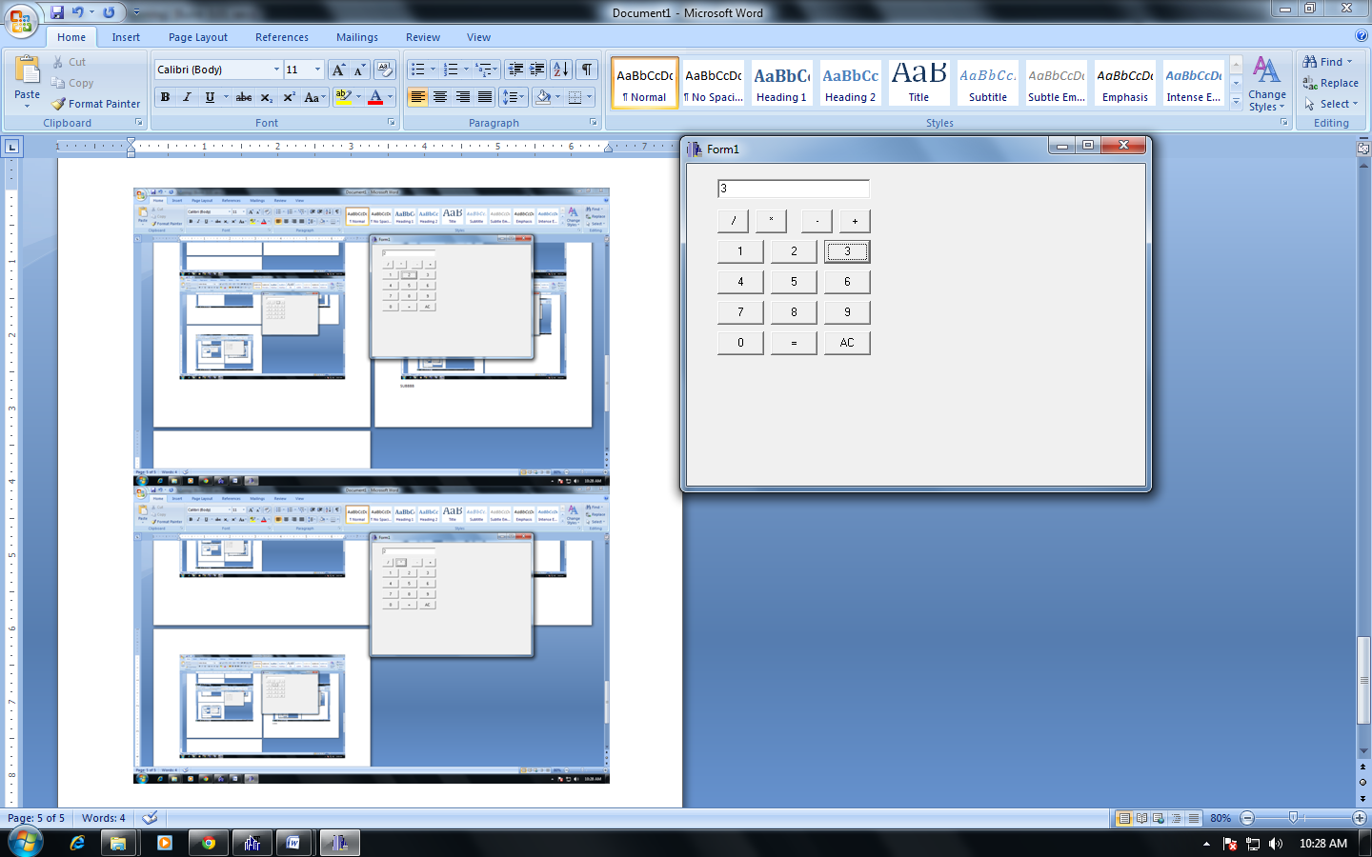

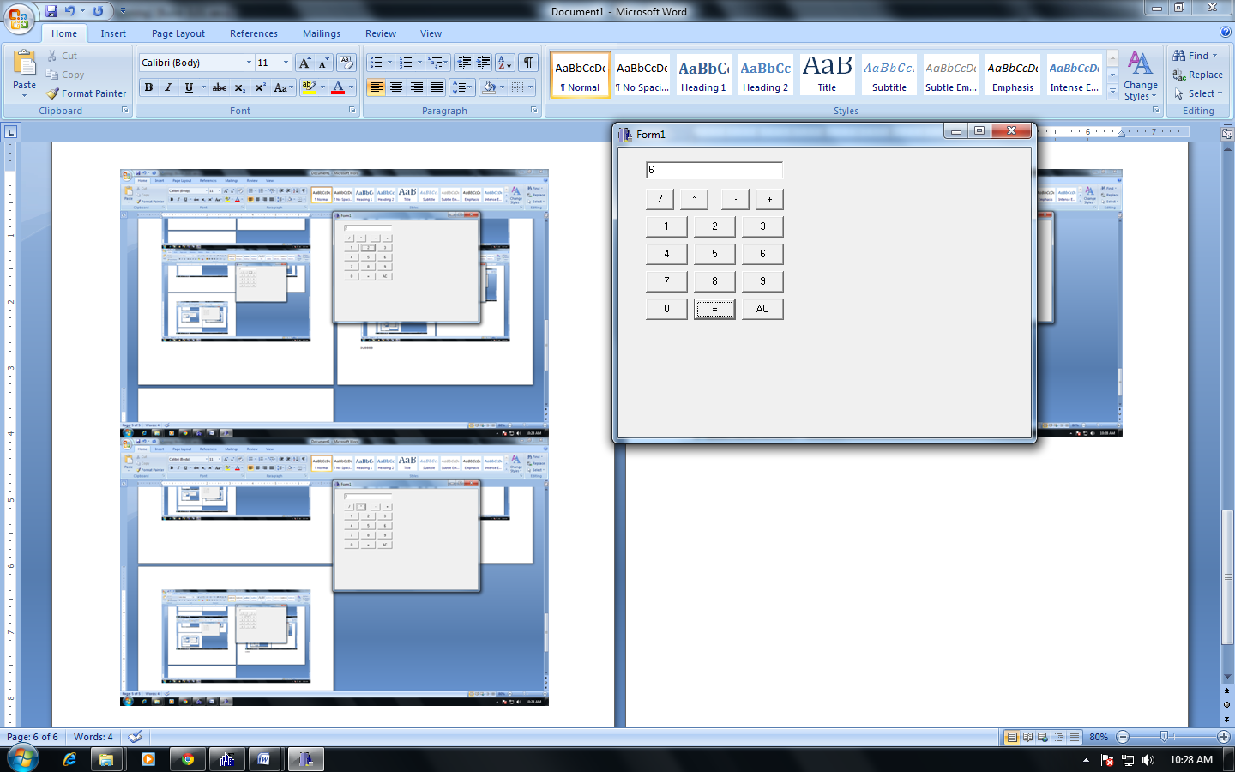

**division**

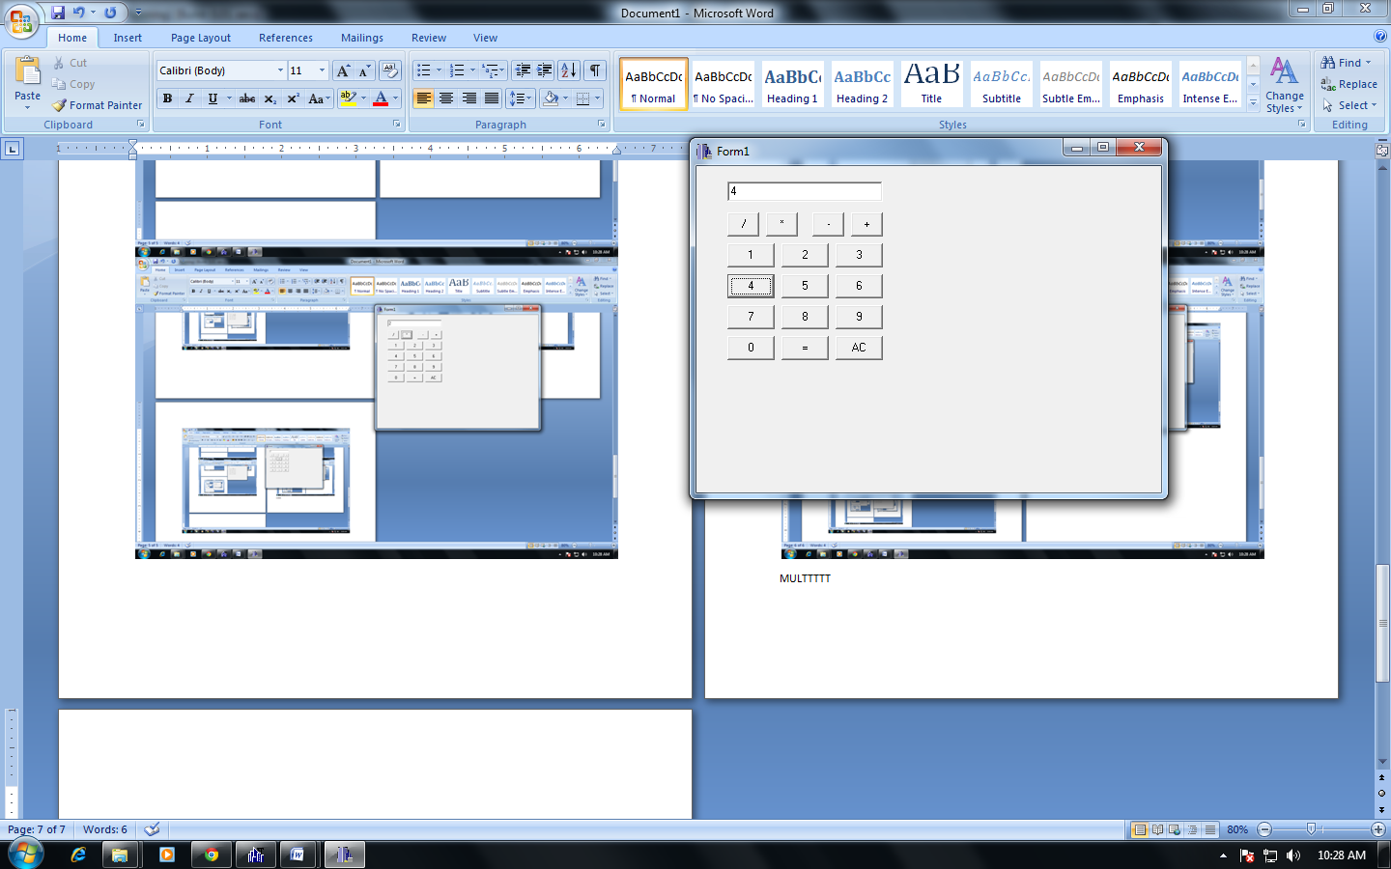

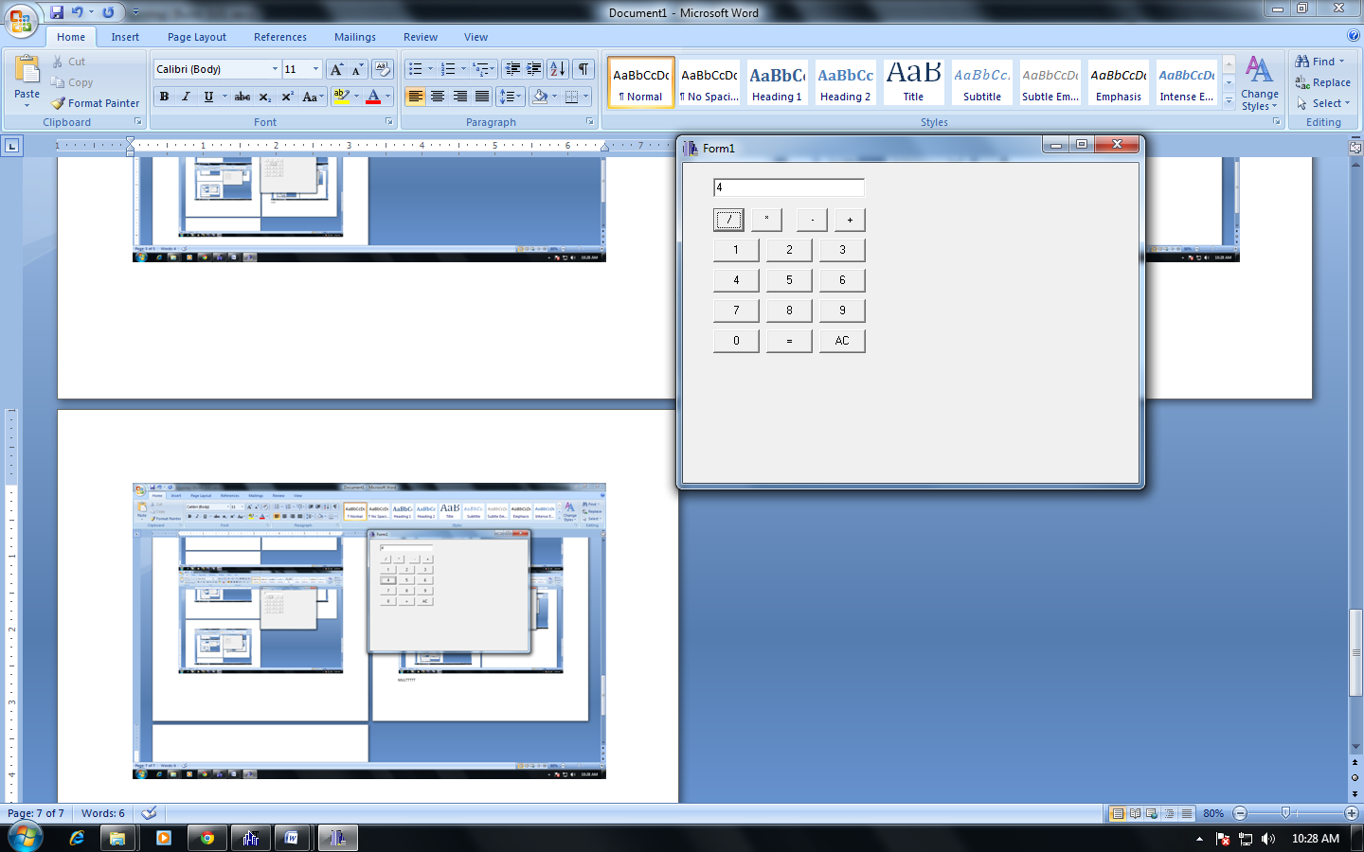

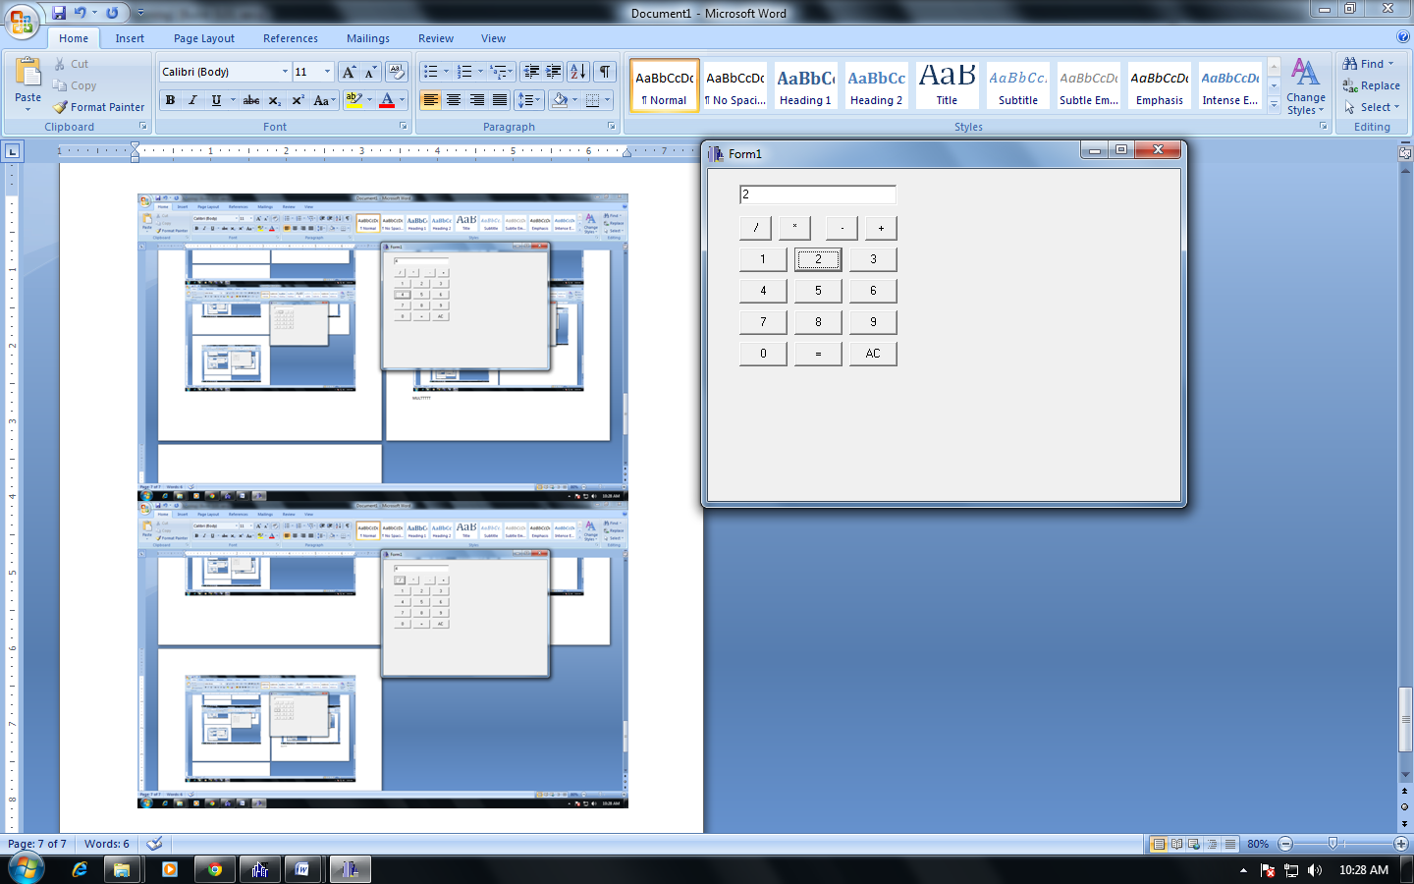

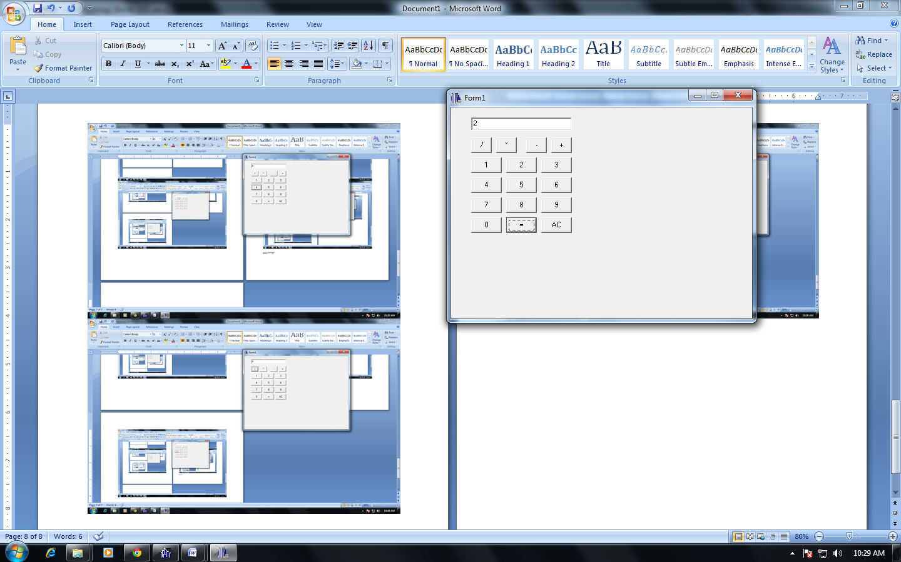

**reset**

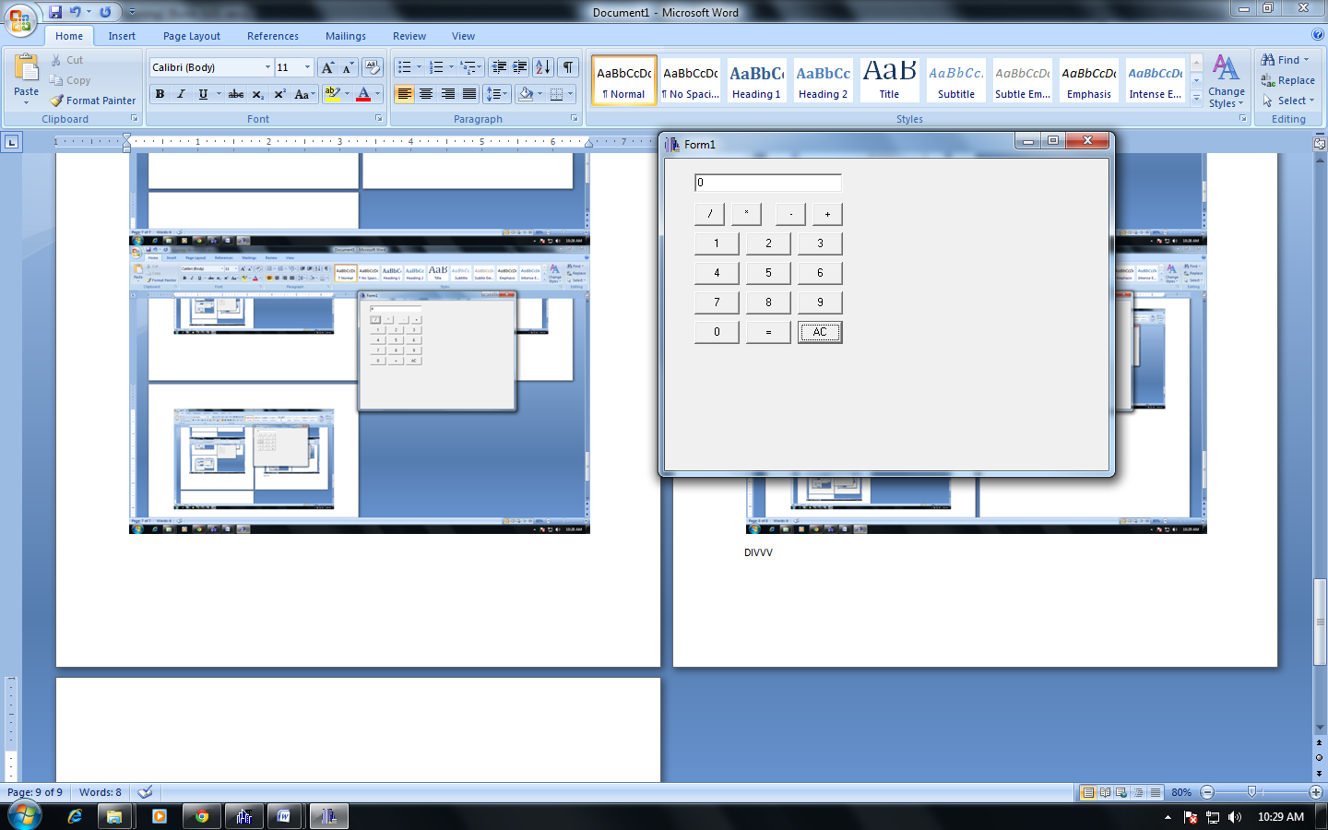

**CONCLUSION**

Hence, a simple calculator was drawn and implemented using C++ builder.